WEMBERLY WORRIED
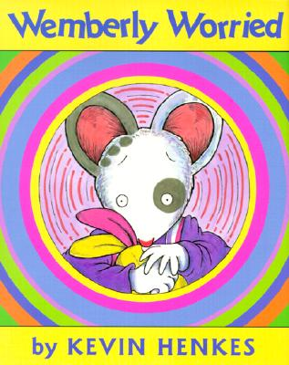
by Kevin Henkes

Narrator 1 Narrator 2 Mother Wemberly
Father Grandmother Mrs. Peachum Jewel

Narrator 2: Wemberly worried about everything. Big things, little things, and things in between.

Narrator 1: Wemberly worried in the morning. She worried at night. And she worried throughout the day.

Mother: “You worry too much,”

Father: “When you worry, I worry,”

Grandmother: “Worry, worry, worry. Too much worry.”

Narrator 1: At home, Wemberly worried about the tree in the front yard, and the crack in the living room wall, and the noise the radiators made.

Narrator 2: At the playground, Wemberly worried about the chains on the swings, and the bolts on the slide, and the bars on the jungle gym. And always, she worried about her doll, Petal.

Mother: “Don’t worry,”

Father: “Don’t worry,”

Narrator 1: But Wemberly worried. She worried and worried and worried.

Narrator 2: When Wemberly was especially worried, she rubbed Petal’s ears. Wemberly worried that if she didn’t stop worrying, Petal would have no ears left at all.

Narrator 1: On her birthday, Wemberly worried that no one would come to her party.

Mother: “See, there was nothing to worry about,”

Narrator 2: said her mother. But then Wemberly worried that there wouldn’t be enough cake.

Narrator 1: On Halloween, Wemberly worried that there would be too many butterflies in the neighborhood parade.

Father: “See, there was nothing to worry about,”

Narrator 2: said her father. But then Wemberly worried because she was the only one.

Mother: “You worry too much,”

Father: “When you worry, I worry,”

Grandmother: “Worry, worry, worry. Too much worry,”

Narrator 1: Soon, Wemberly had a new worry: school. Wemberly worried about the start of
school more than anything she had ever worried about before.

Narrator 2: By the time the first day arrived, Wemberly had a long list of worries.

Wemberly: What if no one else has spots? What is no one else wears stripes? What if no one else brings a doll? What if the teacher is mean? What if the room smells bad? What if they make fun of my name? What if I can’t find the bathroom? What if I hate snack? What if I have to cry?

Mother: “Don’t worry,”

Father: “Don’t worry,”

Narrator 1: said her father. But Wemberly worried. She worried, and worried, and worried. SHE WORRIED ALL THE WAY THERE.

Narrator 2: While Wemberly’s parents talked to the teacher, Mrs. Peachum, Wemberly looked around the room. Then Mrs. Peachum said,

Mrs. Peachum: “Wemberly, there is someone I think you should meet.”

Narrator 1: Her name was Jewel. She was standing by herself. She was wearing stripes. She
was holding a doll.

Narrator 2: At first, Wemberly and Jewel just peeked at each other.

Wemberly: “This is Petal,”

Jewel: “This is Nibblet,”

Narrator 2: Petal waved. Nibblet waved back.

Jewel: “Hi,”

Wemberly: “Hi, I rub her ears,”

Jewel: “I rub her nose,”

Narrator 1: Throughout the morning, Wemberly and Jewel sat side by side and played together whenever they could. Petal and Nibblet sat side by side, too.

Narrator 2: Wemberly worried. But no more than usual. And sometimes even less.
Narrator 1: Before Wemberly knew it, it was time to go home.

Mrs. Peachum: “Come back tomorrow,”

Narrator 2: called Mrs. Peachum, as the students walked out the door. Wemberly turned and smiled and waved. She said,

Wemberly: “I will. Don’t worry.”

Flesch-Kincaid grade level: 3.8 Spache Readability Index: 2.91

